Assessment: End-to-End Enterprise AI Application

Scenario: Intelligent Invoice Processing Assistant
A finance operations team receives hundreds of invoices daily through email and manual uploads. Processing these invoices manually is time-consuming and error-prone.
Your task is to build an AI-powered enterprise application that:
- extracts invoice information using OCR
- processes the extracted content using an LLM
- generates business-friendly summaries and insights

Problem Statement
Build an end-to-end AI application where users can upload invoice documents through a frontend application.
The application should:
- Upload invoice/image/PDF
- Send document to Azure OCR service
- Extract invoice fields
- Pass OCR response to Azure OpenAI
- Generate:
  - invoice summary
  - important business details
  - anomaly/warning detection
- Display final output in frontend

Expected Architecture
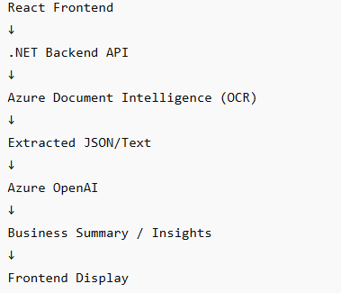

Functional Requirements

Part 1 — Frontend
Build a simple React UI where user can:
- upload invoice PDF/image
- click “Process Invoice”
- view:
  - extracted fields
  - AI-generated summary
  - warnings/anomalies

Part 2 — Backend (.NET)
Backend should:
- receive uploaded file
- call Azure OCR API
- extract:
  - vendor name
  - invoice number
  - invoice date
  - total amount
Then:
- send extracted content to Azure OpenAI

Part 3 — LLM Processing
Use prompt engineering to:
- summarize invoice
- identify suspicious values
- generate business insights
Example Prompt
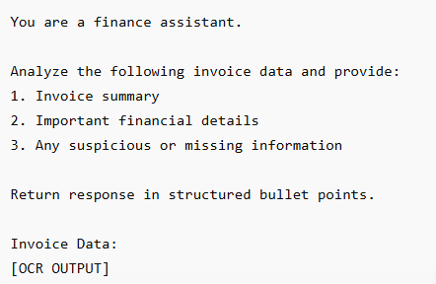

Expected Output Example
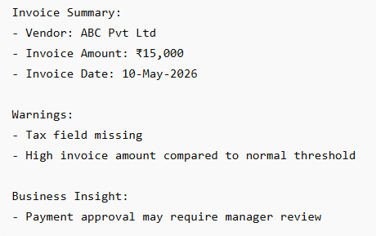

Technical Requirements
Students should demonstrate:
- API consumption
- OCR integration
- LLM prompting
- Backend orchestration
- JSON handling
- Business logic filtering

Optional Enhancements
Students can additionally implement:
- Blob Storage upload
- Downloadable summary report
- Speech-based invoice narration
- Chat interface for invoice Q&A
Evaluation Criteria
Criteria | Marks
Frontend Functionality | 20
Backend Integration | 25
OCR Integration | 20
Prompt Engineering | 15
Response Formatting | 10
Architecture Explanation | 10

React Boilerplate code
